2022-08-05 新设计毫米波雷达测角测试

【静态测试】

场景设置：毫米波雷达

算法选取的参数：

Range cfar thresh = 0.25

Doppler cfar thresh = 0.1

Frame = 4

1. -45°下的结果

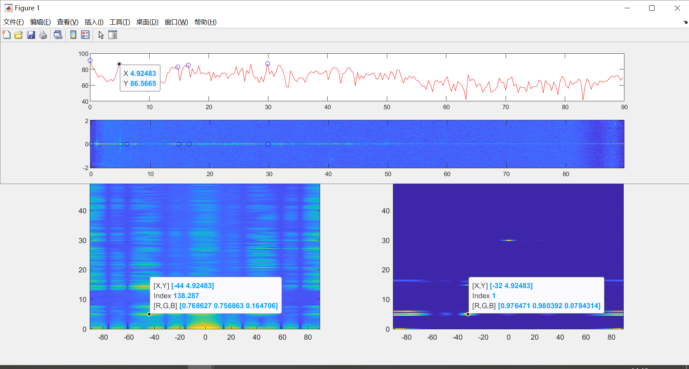

1. -30°

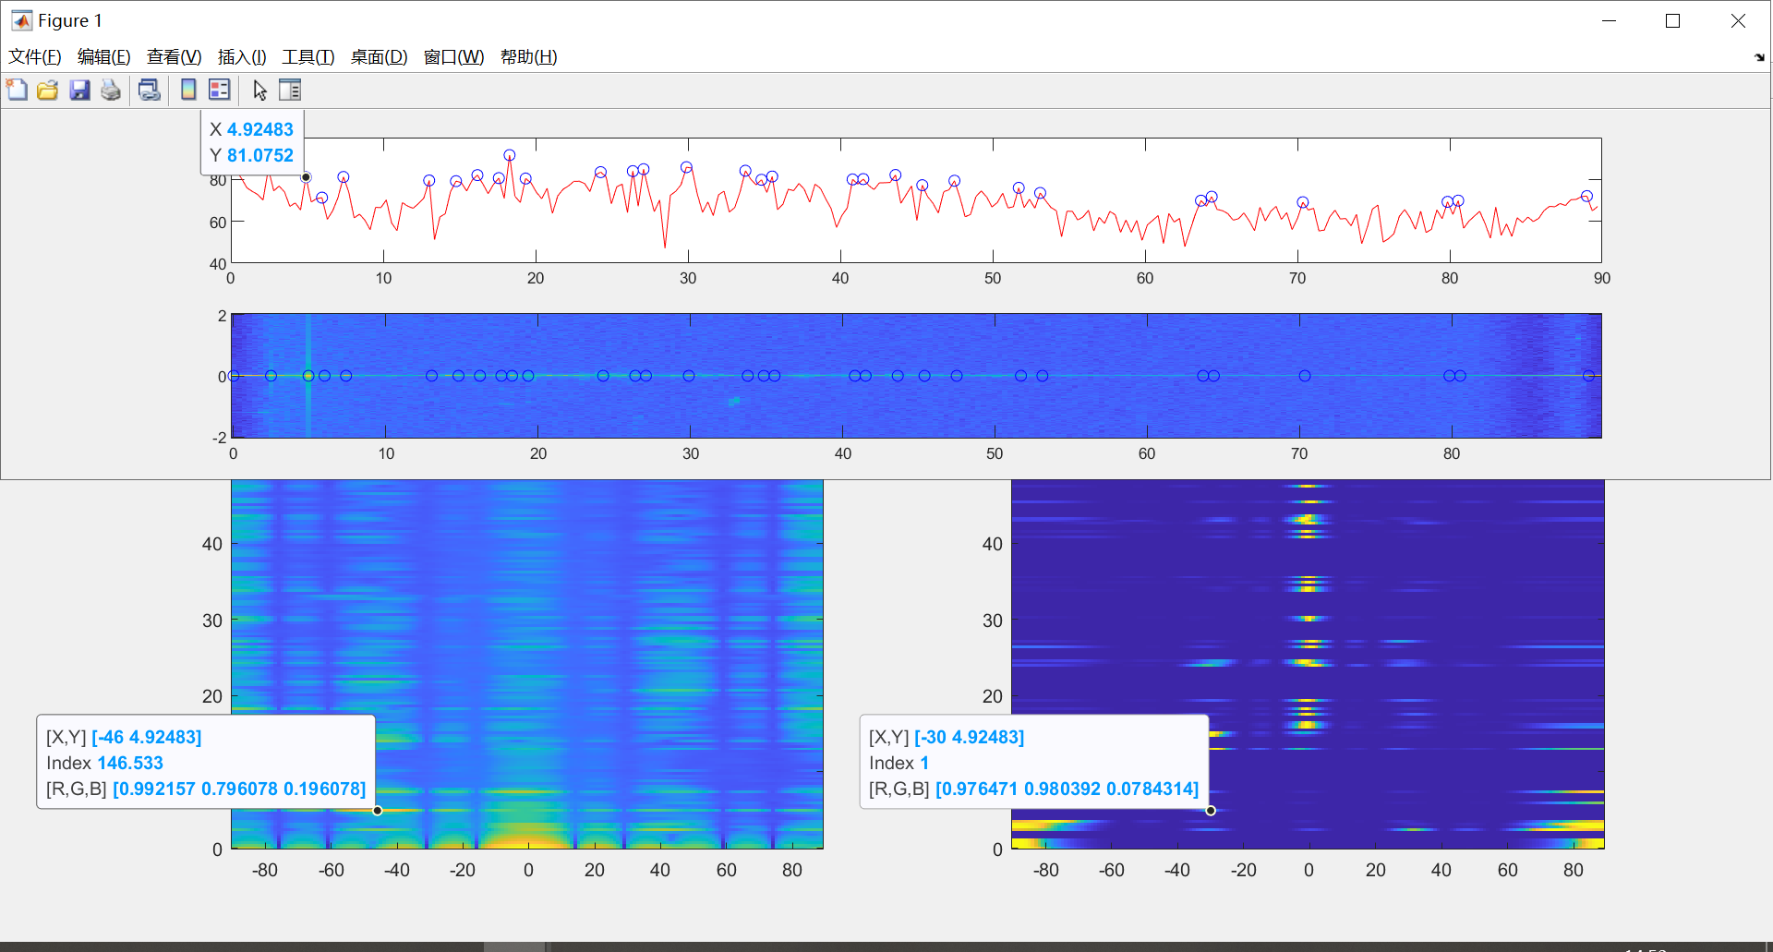

1. -25°

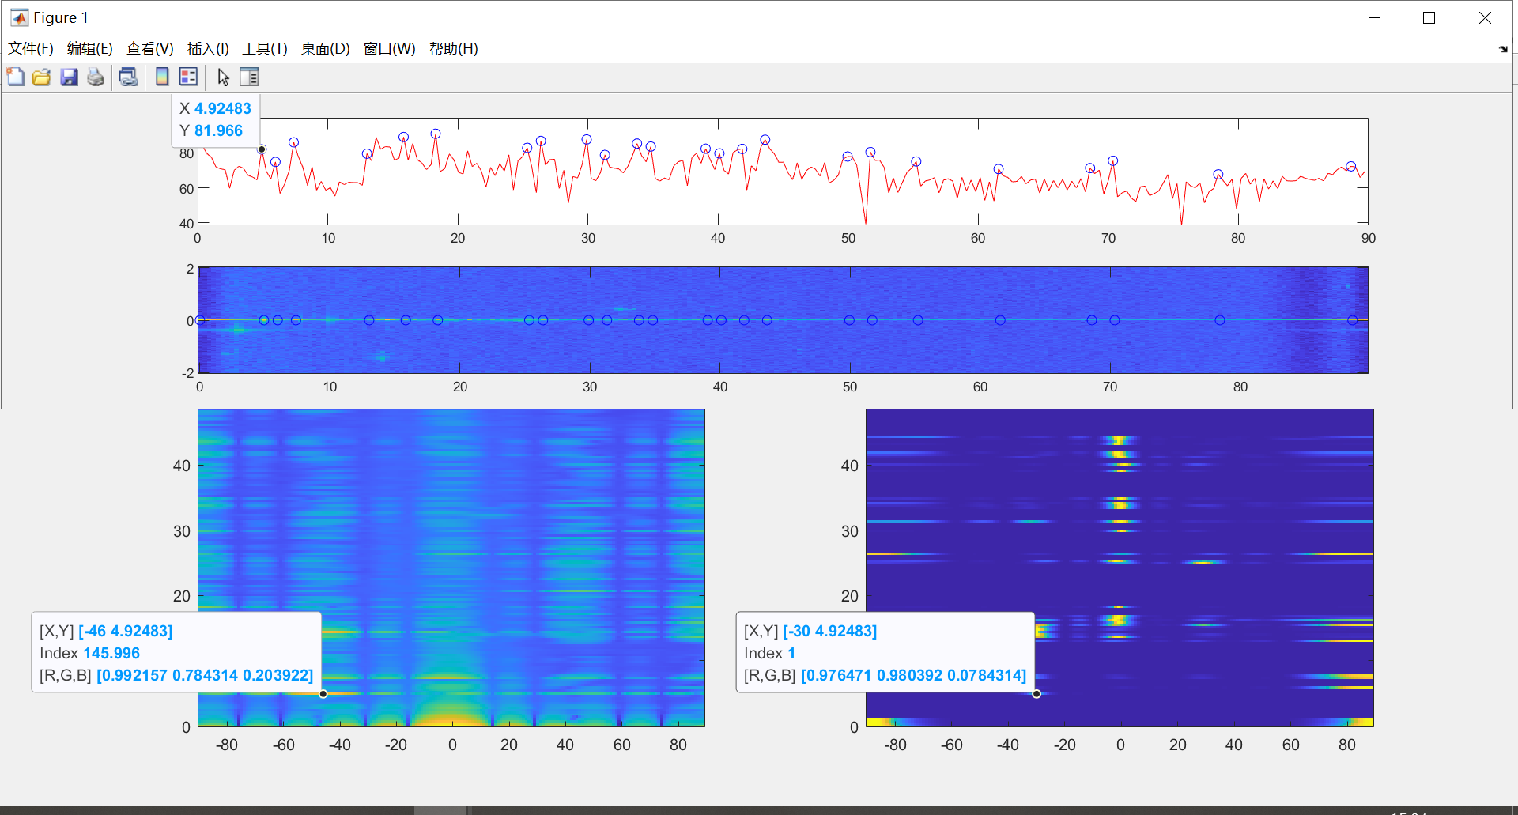

1. -20°

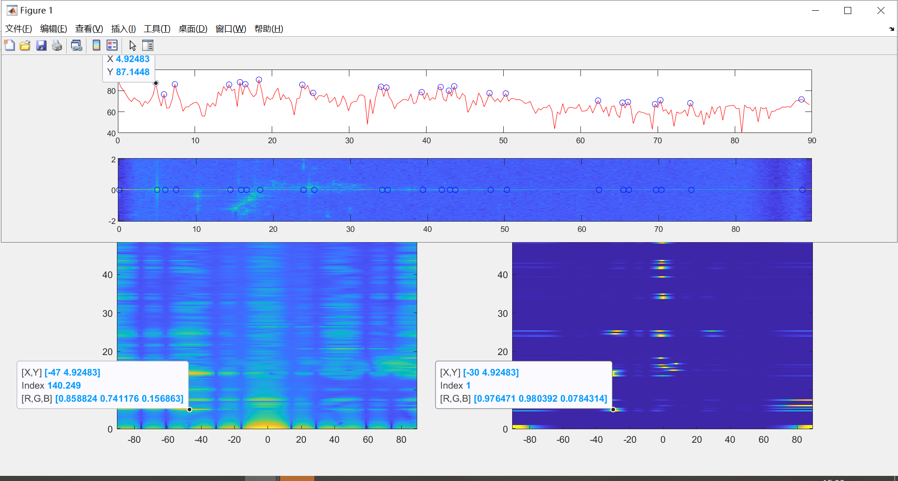

1. -15°

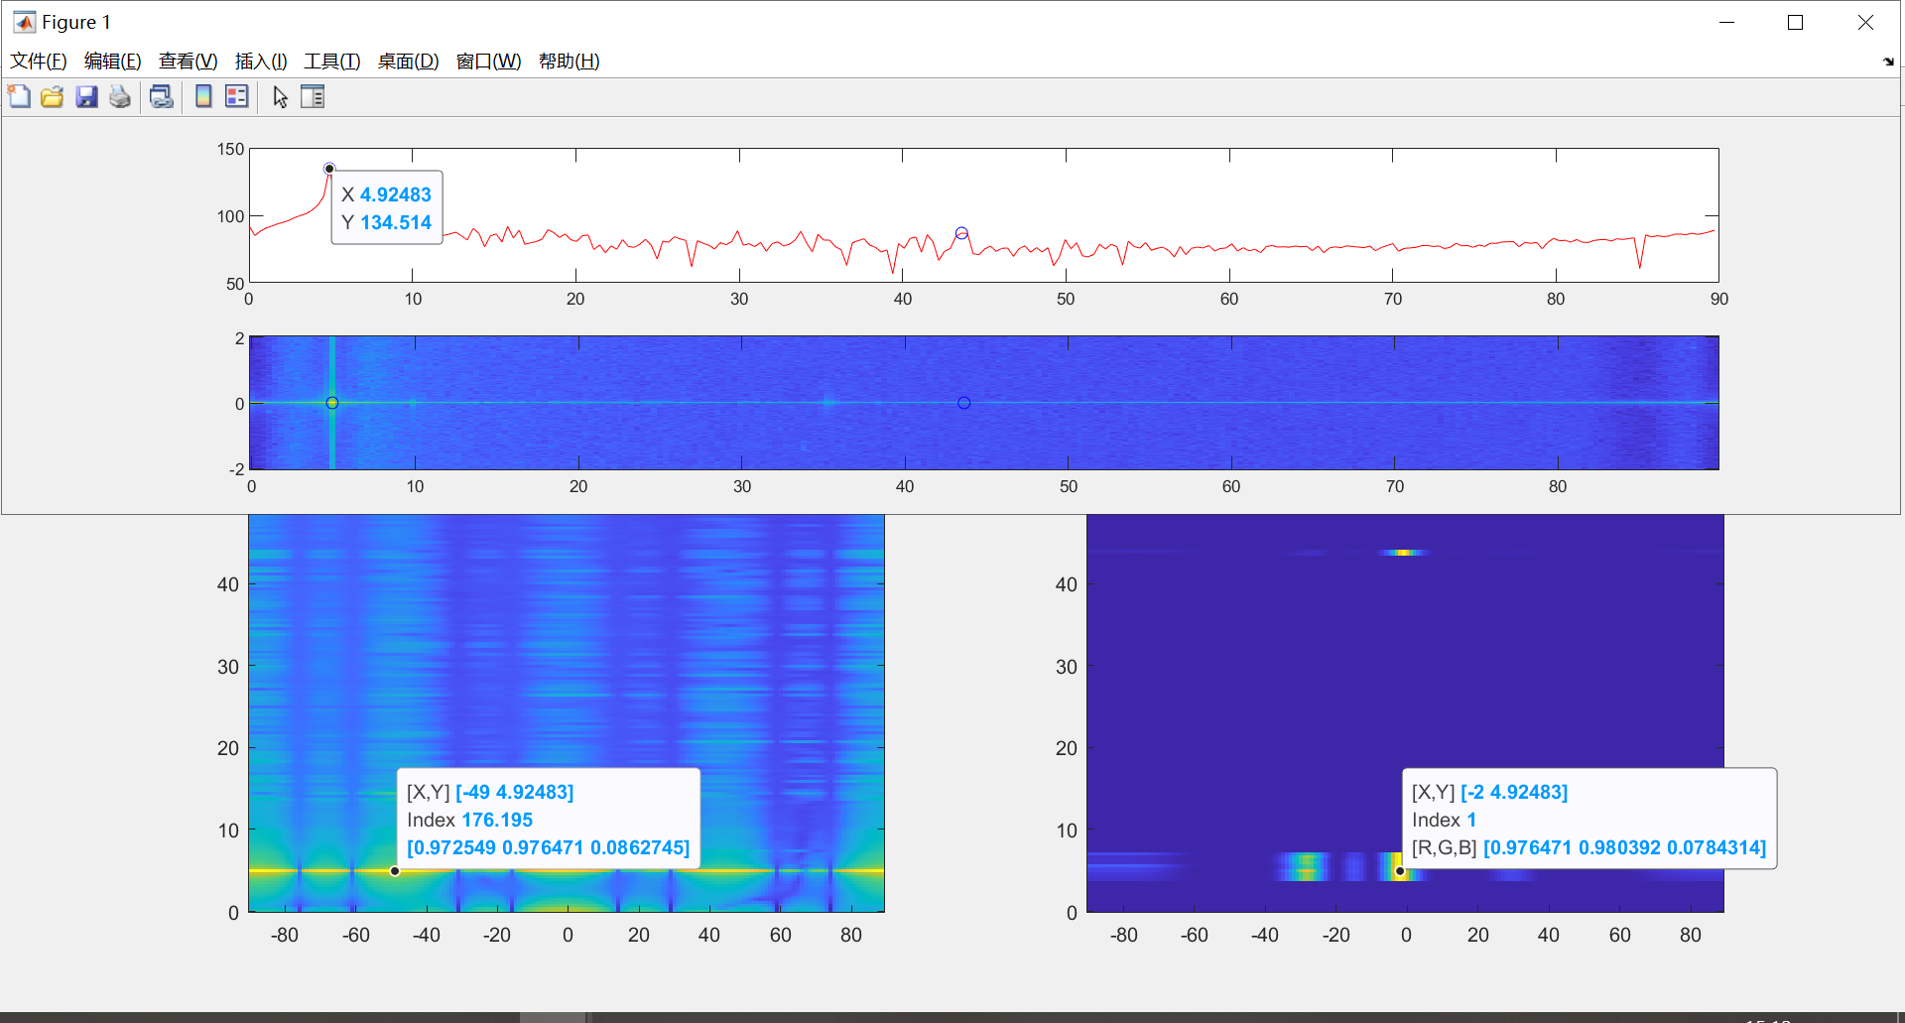

1. -10°

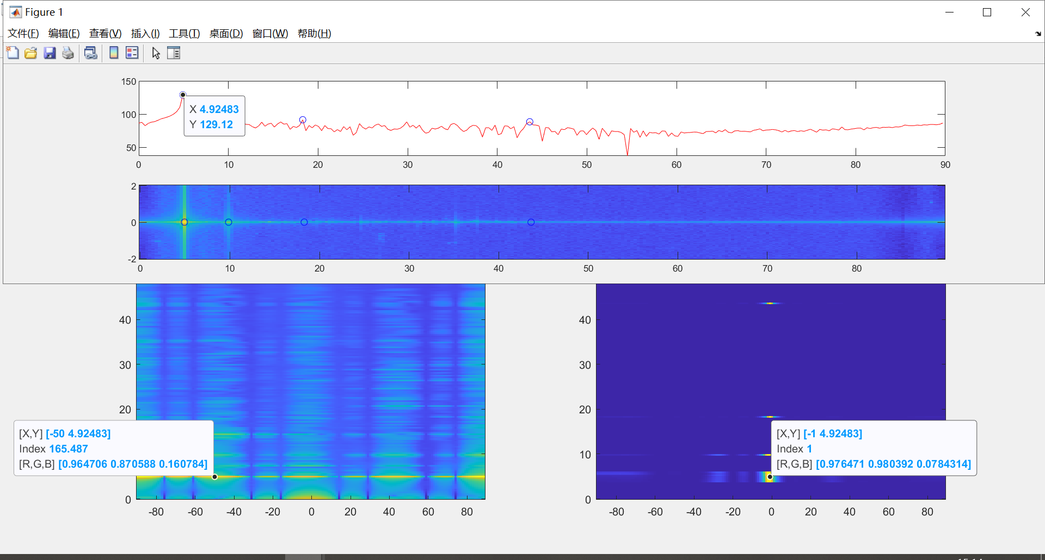

1. -5°

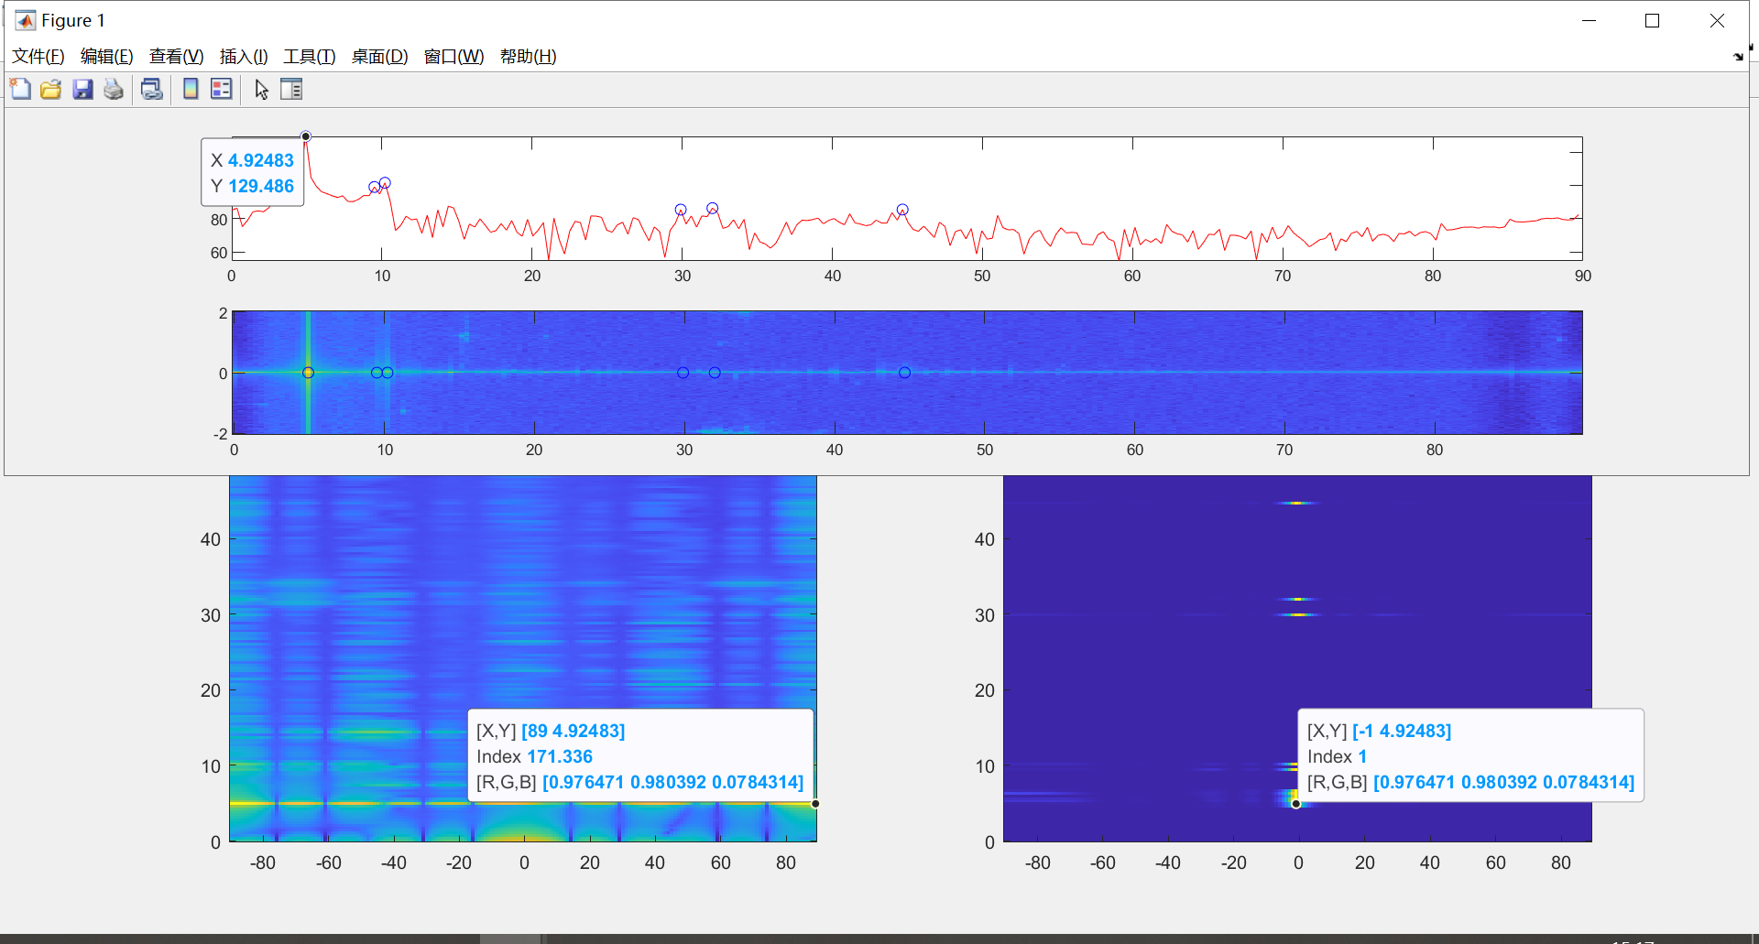

1. 5°

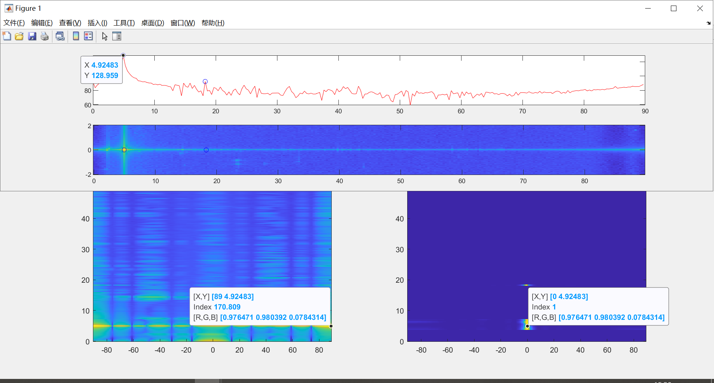

1. 10°

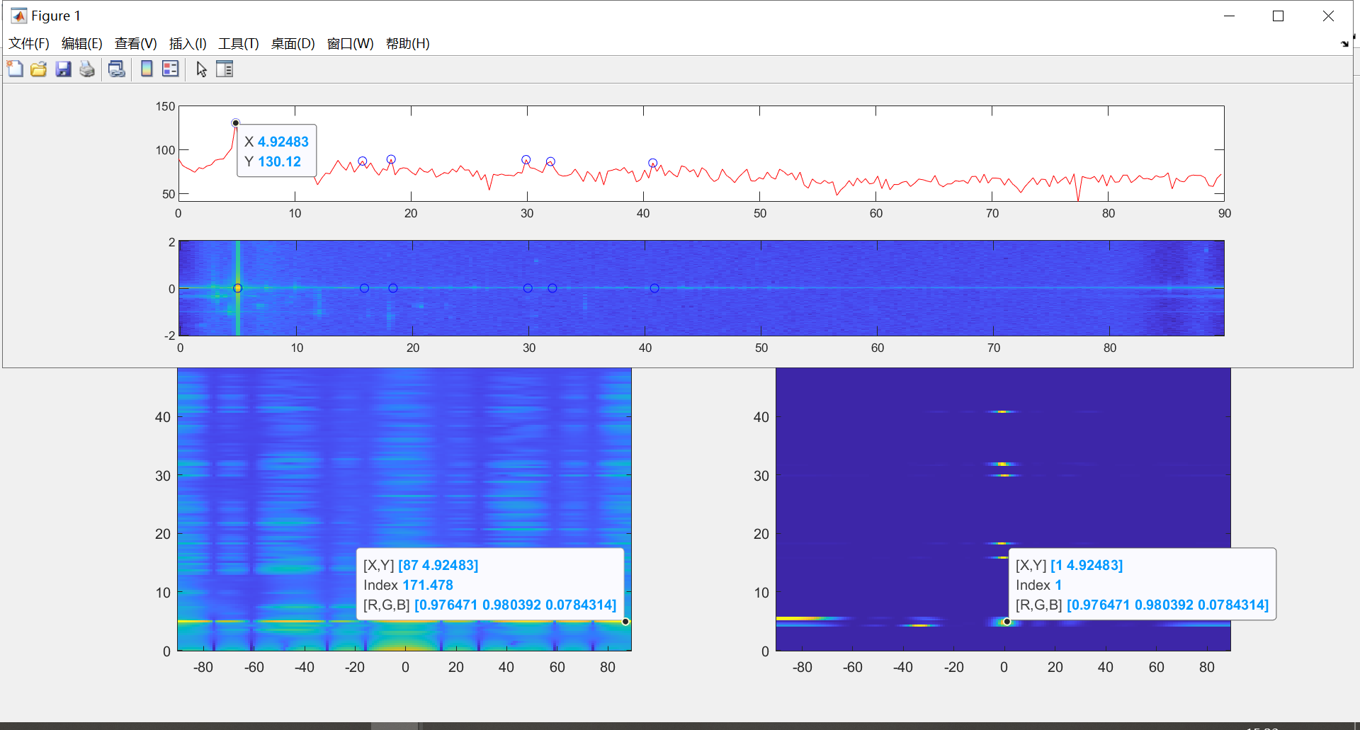

1. 15°

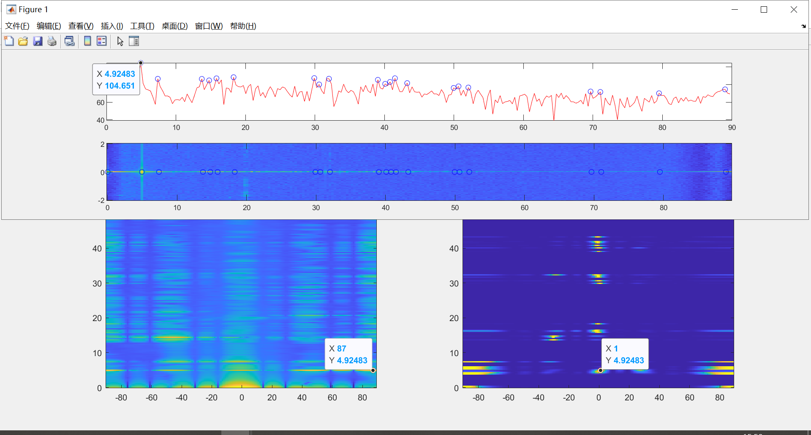

1. 20°

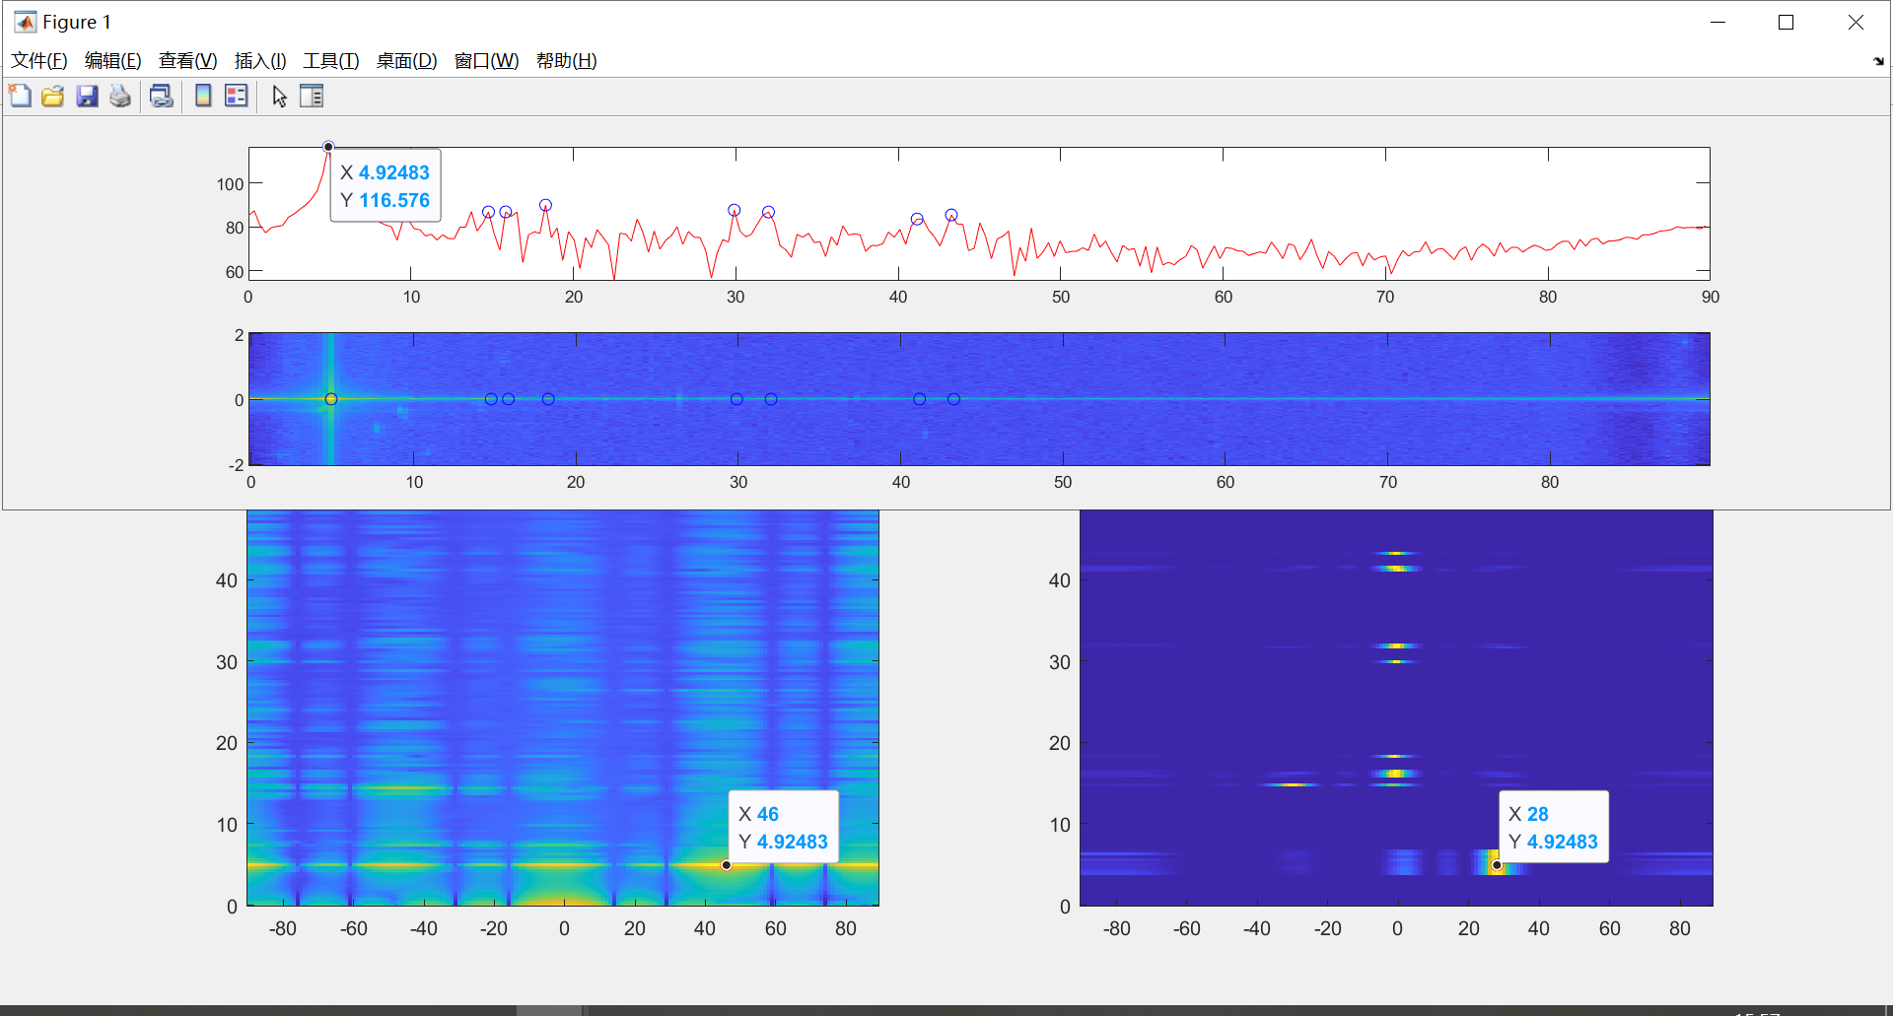

1. 25°

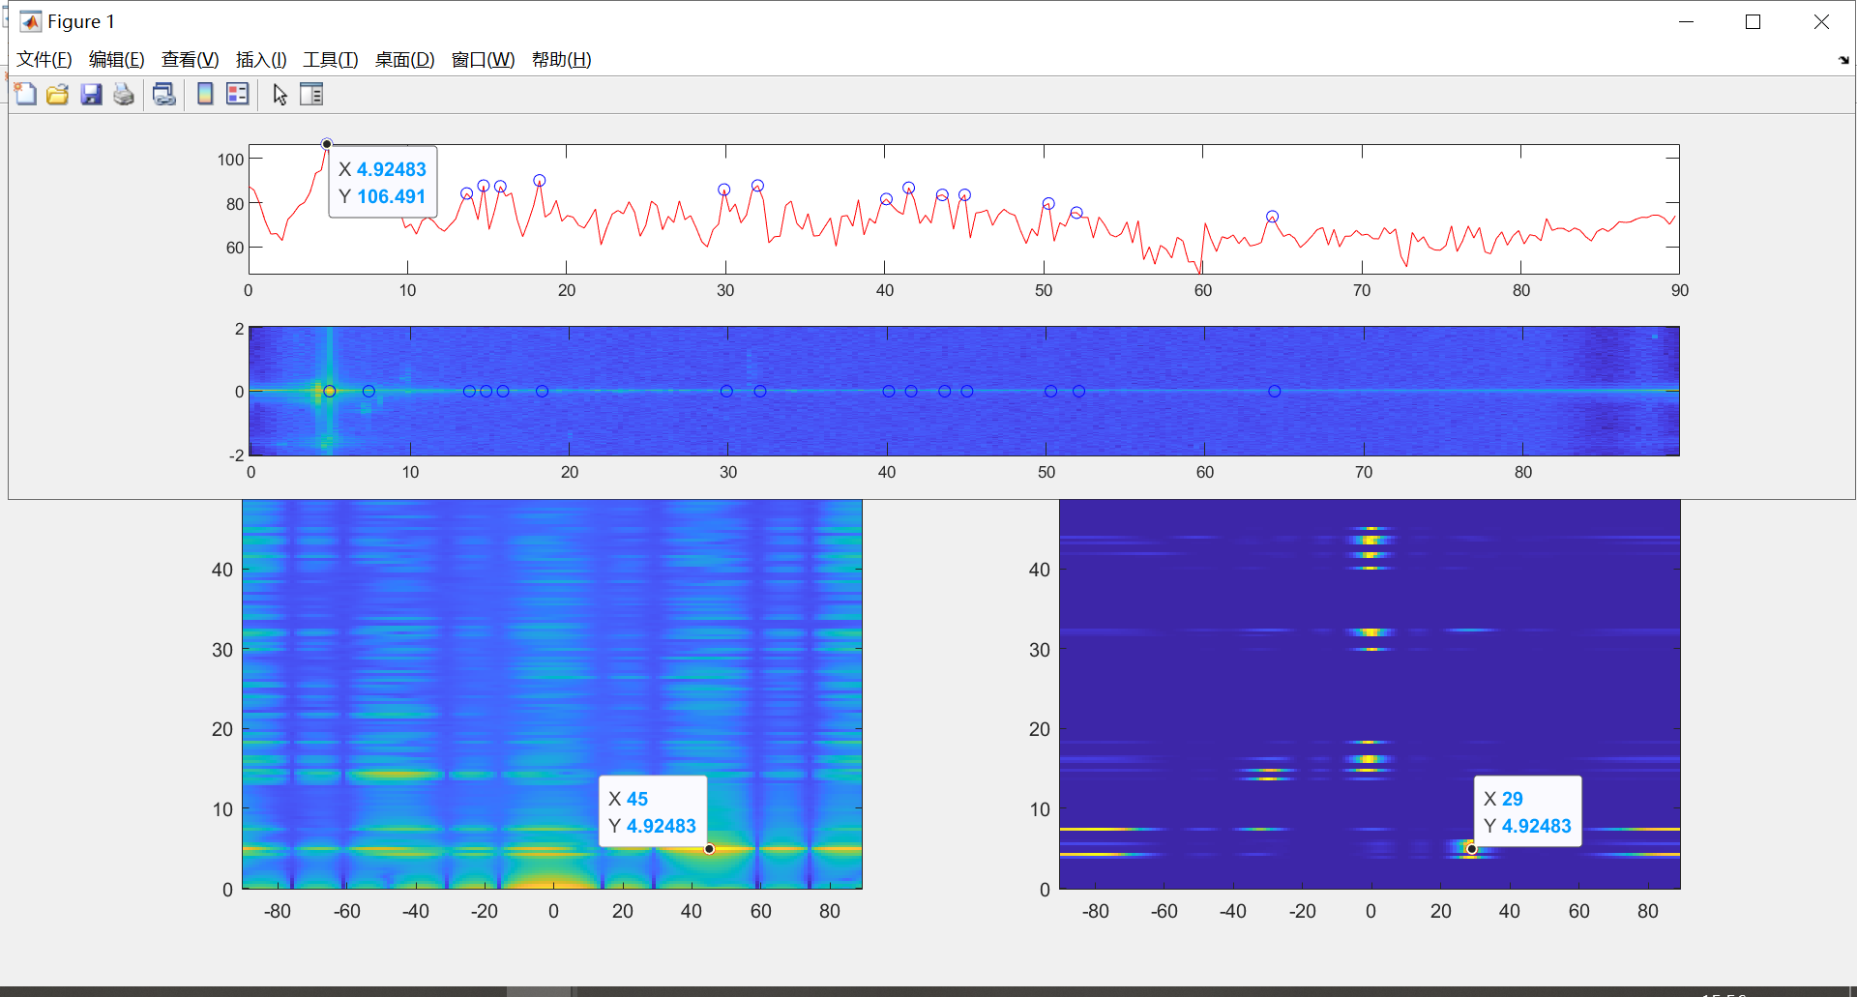

1. 30°

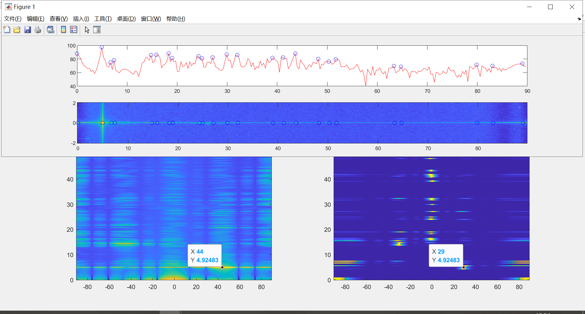

结果表格

|  |  |  |  |  |  |  |  |  |  |  |  |  |  |
| --- | --- | --- | --- | --- | --- | --- | --- | --- | --- | --- | --- | --- | --- |
| Deg | -45 | -30 | -25 | -20 | -15 | -10 | -5 | 5 | 10 | 15 | 20 | 25 | 30 |
| FFT | -44 | -46 | -46 | -47 | -49 | -50 | 89 | 89 | 87 | 87 | 46 | 45 | 44 |
| Music | -32 | -30 | -30 | -30 | -2 | -1 | 1 | 1 | 1 | 1 | 28 | 29 | 29 |

误差曲线

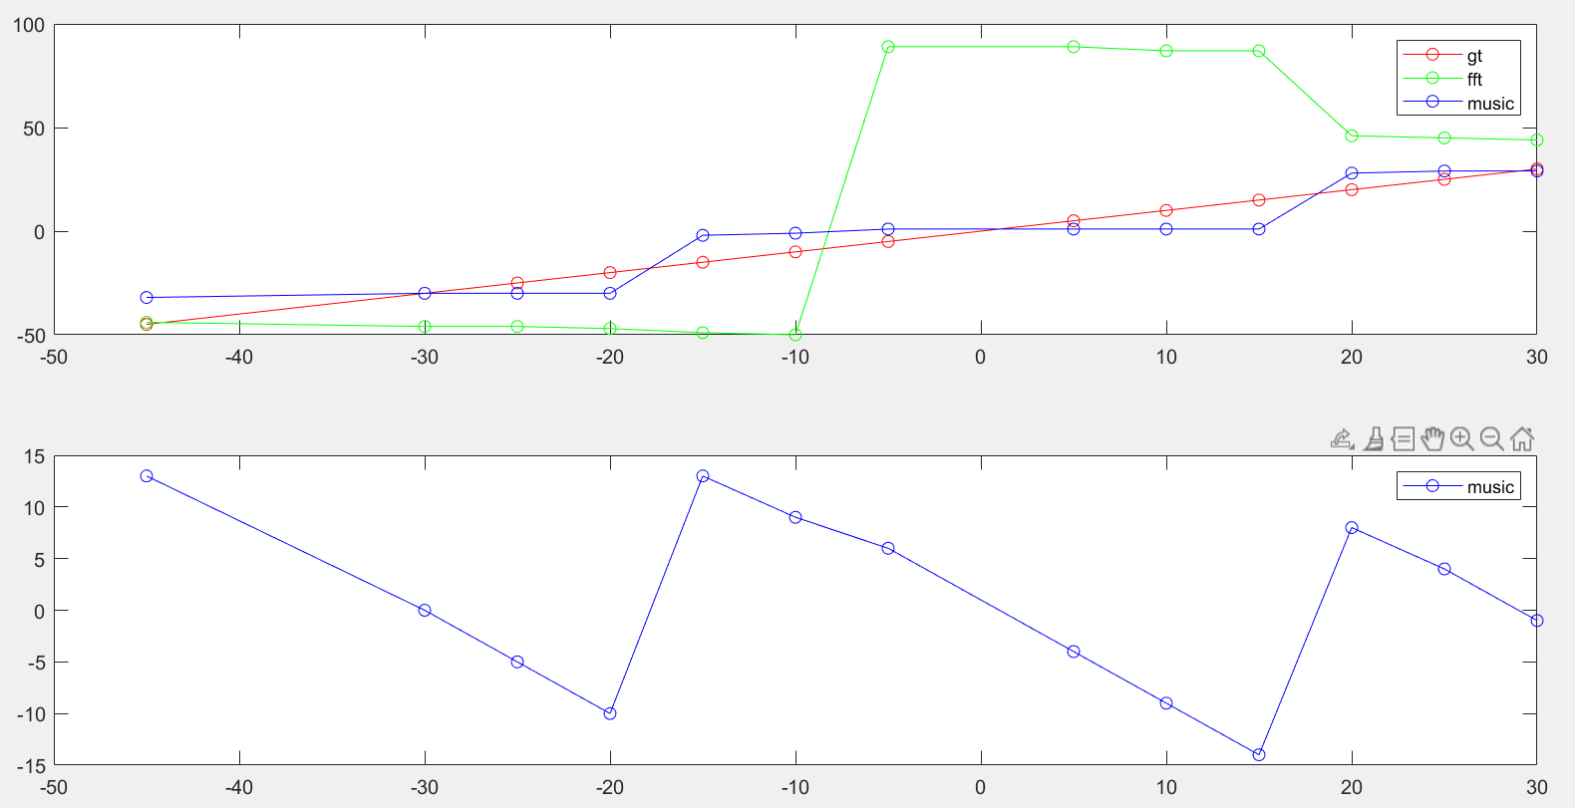

TI板子测角结果图误差曲线

